November 2018 | Green Oaks Inn  Specialty Care Assisted Living
 | 140 Pepper Lane, Florence, AL 35633 (256) 767-2080
Sunday | Monday | Tuesday | Wednesday | Thursday | Friday | Saturday
 | 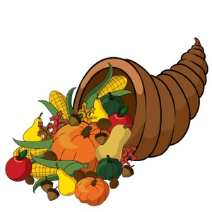 | *Activities subject  to change | *Snacks served each day | 1  Body Recall-10:00 | 2  Atlas Church-Miles Stutts-10:00 | 3  Family Day
Large Group  Activities… | …Thankful, Happy ,Blessed… | ession |  | Underwood Church-  1:30 | Sing- A- Long  - 2:00
4 | 5 | 6 | 7 | 8 | 9 | 10
CHURCH  Petersville - 1:30 | Wheel of Fortune -10:00  Reminisce w/Friends  - 2:00 | Body Recall - 10:00  Current Events-2:00 | Olen & Nancy singing - 10:00  C/H - Social Time-2:00  Bingo Social P/H | Body Recall - 10:00  Thanksgiving Lunch with family -12:00  Underwood Church  - 1:30 | Parachute Fun!-10:00  Sing-A-Long - 2:00 | Family Day
11 | 12 | 13 | 14 | 15 | 16 | 17
 | Veterans Day program….Larry Miller -10:00  Michael Darling-2:00 | Body Recall - 10:00  Devotional- 2:00 | GRACE NOTES - 10:00  Games w/Friends -  C/H - 2:00  Bingo Social P/H | Body Recall - 10:00  Underwood Church  - 1:30 | Crafts with Cyndi  - 10:00  Sing- A -Long - 2:00 | Family Day
18 | 19 | 20 | 21 | 22 | 23 | 24
CHURCH  Stony Point - 1:30 | Wheel of Fortune - 10:00  Balloon Volley - 2:00 | Body Recall - 10:00  Birthday Party with  Butterbean Band - 2:00 | STONY POINT  Devotion - 10:00  Games w/Friends -  C/H - 2:00  Bingo Social P/H - 3:00 | Macy's Thanksgiving Day Parade on tv  Thanksgiving Feast-12:00  - | Socialtime w/Friends  - 10:00  Sing-A-Long - 2:00 | Family Day  AL vs Auburn game
25 | 26 | 27 | 2828 | 29 | 3030
CHURCH  Christ Chapel-1:30 | Wheel Of Fortune - 10:00  Volley Ball Fun! - 2:00 | Body Recall - 10:00  Garage Band  - 2:00 | Book Club - 10:00  C/H Social Time  Bingo Social P/H- 2:00 | Body Recall -10:00  Underwood Church-2:00 | Christmas Decorating -10:00  Underwood Church-2:00

